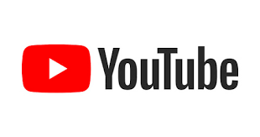

**Product Dissection for YouTube**

### **Company Overview:**

**YouTube** is an American [online video-sharing](https://en.wikipedia.org/wiki/Online_video_platform) and [social media](https://en.wikipedia.org/wiki/Social_media) platform owned by [Google](https://en.wikipedia.org/wiki/Google). Accessible worldwide, it was launched on February 14, 2005, by [Steve Chen](https://en.wikipedia.org/wiki/Steve_Chen), [Chad Hurley](https://en.wikipedia.org/wiki/Chad_Hurley), and [Jawed Karim](https://en.wikipedia.org/wiki/Jawed_Karim), three former employees of [PayPal](https://en.wikipedia.org/wiki/PayPal). Headquartered in [San Bruno, California](https://en.wikipedia.org/wiki/San_Bruno,_California), [United States](https://en.wikipedia.org/wiki/United_States), it is the [second most visited](https://en.wikipedia.org/wiki/List_of_most_visited_websites) website in the world, after [Google Search](https://en.wikipedia.org/wiki/Google_Search). YouTube has more than 2.5 billion monthly users, who collectively watch more than one billion hours of videos every day. As of May 2019, videos were being uploaded to the platform at a rate of more than 500 hours of [content](https://en.wikipedia.org/wiki/Content_(media)) per minute, and as of 2023, there were approximately 14 billion videos in total.

### **Product Dissection and Real-World Problems Solved by YouTube:**

YouTube is a video-sharing platform that allows users to upload, share, and view videos on a wide range of topics.

YouTube hosts an immense variety of content, including music videos, vlogs (video blogs), tutorials, educational videos, entertainment clips, news segments, documentaries, and more. Users can find content on almost any topic imaginable. Anyone with an internet connection and a camera can create and upload videos to the platform, democratizing media production and distribution.

YouTube offers various ways for content creators to monetize their videos. This includes displaying ads, joining the YouTube Partner Program, selling merchandise through the YouTube Merchandise Shelf, and receiving donations from viewers through features like channel memberships.

YouTube fosters interaction and engagement between content creators and viewers through features such as likes, comments, shares, and subscriptions. Creators can communicate directly with their audience, receive feedback, and build communities around their channels.

YouTube uses sophisticated algorithms to recommend videos to users based on their viewing history, preferences, and behaviour.

With over 2 billion logged-in monthly users as of 2021, YouTube has a vast global reach. Content creators can reach audiences around the world, transcending geographical boundaries and language barriers.

YouTube provides educational resources for creators, including tutorials, best practices guides, and creator support programs. These resources help creators improve their content, grow their channels, and navigate the platform's features and policies.

In conclusion, YouTube has revolutionized the way people consume and interact with video content, becoming a central hub for entertainment, information, education, and communication in the digital age.

### **Case Study: Real-World Problems and YouTube's Innovative Solutions**

Users faced several challenges related to accessing and sharing video content online. YouTube addressed many of these problems with its innovative platform. Here are some of the key issues users faced before YouTube and the solutions it provided:

#### **Problem 1: Limited Video Hosting**

**Real-World Challenge:** Hosting and streaming videos online was complex and often required specialized knowledge and resources. Users had to rely on personal websites, file-sharing services, or dedicated video hosting platforms with limited features and high costs.

**YouTube's Solution:**

YouTube provided a user-friendly platform for hosting and streaming videos at no cost to users. By handling the technical aspects of video hosting and encoding, YouTube made it easy for anyone to upload and share videos with a global audience.

#### **Problem 2: Fragmented Content**

**Real-World Challenge:** The video content was fragmented across various websites, making it difficult for users to discover and access the videos they were interested in. Finding specific videos often required navigating multiple websites and platforms

**YouTube's Solution:**

YouTube centralized video content on a single platform, making it easy for users to search for and discover videos on virtually any topic. Its robust search and recommendation algorithms helped users find relevant content quickly and efficiently.

#### **Problem 3: Poor Video Quality**

**Real-World Challenge:** Pre-YouTube video streaming technologies often resulted in low-quality video playback, buffering issues, and slow loading times. Users had to contend with pixelated videos and frequent interruptions, especially on slower internet connections.

**YouTube's Solution:**

YouTube pioneered advances in video compression and streaming technology, delivering high-quality video playback even on lower bandwidth connections. Its adaptive streaming algorithms dynamically adjust video quality based on available bandwidth, ensuring smooth playback and minimizing buffering

#### **Problem 4: Lack of Monetization Opportunities**

**Real-World Challenge:** There were limited opportunities for content creators to monetize their videos online. Advertisers and sponsors often preferred traditional media platforms, and individual creators had few avenues to generate revenue from their content.

**YouTube's Solution:**

YouTube introduced various monetization options for content creators, including ad revenue sharing, channel memberships, Super Chat donations, and merchandise sales. These monetization features empowered creators to earn income from their videos and build sustainable careers on the platform.

#### **Conclusion:**

YouTube revolutionized the online video landscape by providing a comprehensive solution to users' challenges before its inception. Its user-friendly interface, advanced technology, robust copyright management systems, and monetization opportunities have made it the leading platform for video sharing and consumption worldwide.

### **Top Features of YouTube:**

1. **User Channels:** YouTube allows users to create personal Channels, offering insights into their lives through features such as usernames, full names, bios, and profile pictures. This creates a personalised online presence that reflects each user's identity.
2. **Video Upload and Hosting:** YouTube allows users to upload videos of various formats and lengths to their channels. It provides reliable hosting services, ensuring that uploaded videos are accessible to viewers around the world
3. **Comments and Interactivity:** YouTube enables viewer interaction through comments, likes, dislikes, and shares. Users can leave comments on videos to express their thoughts, ask questions, or engage in discussions with other viewers and creators.
4. **Subscription System:** Users can subscribe to channels they enjoy, allowing them to receive notifications and updates whenever new videos are uploaded. Subscriptions help users stay connected with their favourite creators and discover new content regularly.
5. **Video Discovery and Recommendations:** YouTube's recommendation algorithms analyze user behaviour and preferences to suggest personalized video recommendations on the homepage and in search results. This feature helps users discover new content aligned with their interests.
6. **Search Functionality:** YouTube's search function enables users to find specific videos, channels, or topics quickly. Users can filter search results by relevance, upload date, view count, and other criteria to find the content they're looking for.

### **Schema Description:**

The schema for YouTube involves multiple entities that represent different aspects of the platform. These entities include Users, Posts, Comments, Likes, Followers, Hashtags, and more. Each entity has specific attributes that describe its properties and relationships with other entities.

**Users Table:**

Users are at the core of YouTube. The user Table contains information about each user:

* **UserID (Primary Key)**: A unique identifier for each user.
* **Username**: The chosen username for the user's account.
* **Email**: The user's email address for account-related communication.
* **Password**: The Password to login to the user channel
* **Bio**: A brief description that users can use to express themselves.
* **Registration_Date**: The date when the user joined Youtube.
* **Profile Picture:** The Image of the Account holder

**Videos Tables:**

Video tables capture the video content shared on the platform:

* **VideoID (Primary Key**)**:** A unique identifier for each video.
* **UserID (Foreign Key referencing Users.UserID):** The user who created the post.
* **Title:** The Heading given to the video.
* **Description:** It describes the content of the video.
* **Upload Date:** The date on which video was uploaded.
* **Duration:** Duration of the video.
* **Views Count:** Number of people who saw the video.
* **Thumbnail:** It is like the cover of your video.
* **Video File Path (or URL):** The URL of the video content.

**Comments Table:**

Comments enable users to engage in conversations around posts:

* **CommentID (Primary Key)**: A unique identifier for each comment.
* **VideoID (Foreign Key referencing Post Entity):** The Vedio is being commented on.
* **UserID (Foreign Key referencing User Entity)**: The user who posted the comment.
* **Comment Text:** The text of the comment.
* **Comment_Date**: The date when the comment was posted.
* **Likes Count:** The Count of likes on the comment

**Like Table:**

Likes represent user appreciation for posts:

* **LikeID (Primary Key):** A unique identifier for each like.
* **VideoID (Foreign Key referencing Post Entity):** The video being liked.
* **UserID (Foreign Key referencing User Entity):** The user who liked the post.
* **Like_Date:** The date when the like was registered.
* **Type(Like/dislike):** The User likes or dislikes the video

**Subscriptions Table:**

Subscriptions establish connections between users:

* **SubscriptionID (Primary Key)**: A unique identifier for each follower relationship.
* **SubscriberUserID (Foreign Key referencing Users.UserID):** The user who is being subscribed.
* **ChannelUserID (Foreign Key referencing Users.UserID)**: The user who is subscribing.
* **Subscription Date:** The date when the following relationship was initiated.

**Categories Table:**

Categories and group the video content:

* **CategoryID (Primary Key):** A unique identifier for each Category.
* **CategoryName:** The actual name of the category.

**Tags Table**

Tags categorise and group content:

* **TagID (Primary Key):** A unique identifier for each Tag.
* **TagName:** The actual name or text of the tag.

**Relationships are:**

* **Users post Videos –** Each user can post multiple videos.
* **Users comment on videos –** Users can comment on multiple Videos, and each Video can have multiple comments.
* **Users like videos –** Users can like or dislike multiple videos, and each video can have multiple likes and dislikes.
* **Users Subscribe Other Users –** Users can subscribe to multiple users and be followed by multiple users.
* **Videos have tags –** Videos can have multiple tags, and each tag can be associated with multiple videos.

**ER Diagram:**

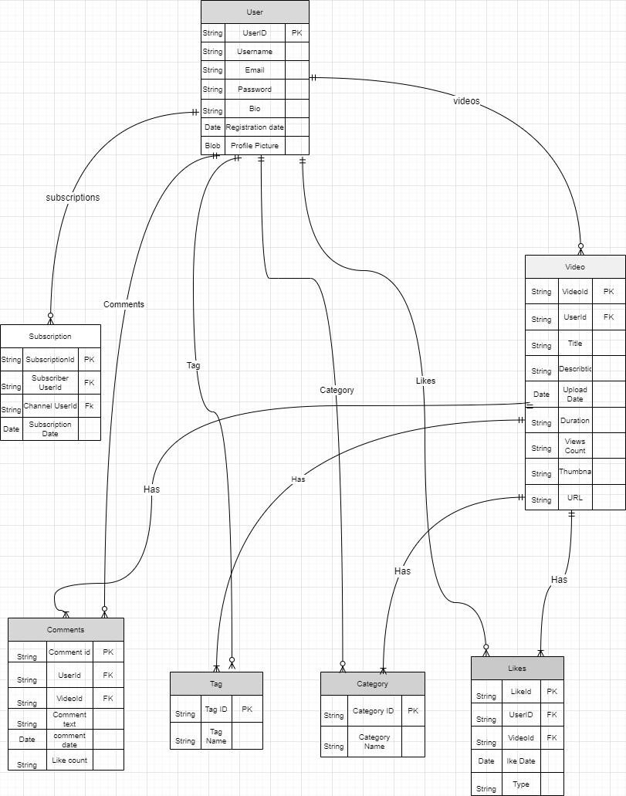

### 

### **Conclusion**

In this case study, we delved into the design of YouTube's schema and Entity-Relationship diagram. YouTube has revolutionized the way people share and engage with visual Video content, fostering connections and creative expression. The platform's intricate data model, consisting of entities like users, posts, comments, likes, Subscribers, tags, and associations, forms the foundation for its seamless functionality. By understanding this schema, we gain insight into how YouTube effectively manages the complexities of user interactions and content sharing, contributing to its widespread popularity and continued growth in the world of social media.